VIKING DEFECT ANALYZES REPORT
Table of contents
1. Purpose of document 1
2. Defect life cycle 1
3. Defect statistics 2
4. Defect by severity 4
5. Defect by tester 5
6. References 6

Purpose of document
Purpose of this document analyzes the provided Viking product defect data and base on data are analyzed, this document to specify steps that should be taken to ensure that quality in aspect of product quality and team project quality include process, resource, productivity of team
The defect data in this document assignment will be collected from “Viking_Product_Defect_Data.xls”

Defect life cycle
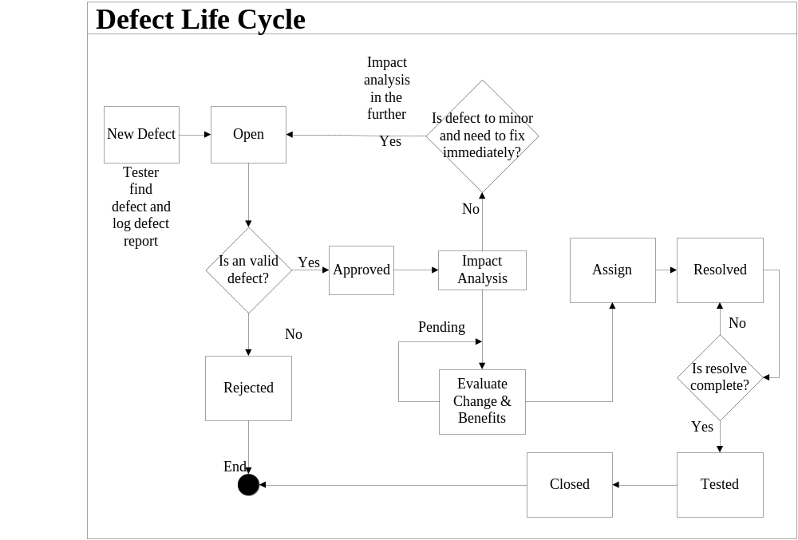
Status | Status Meaning
Open | New, not yet assigned
Reopen | A defect that was previously Closed, Pending or Rejected has been Reopened. Typically this means that the Customer or QA has been able to reproduce the defect.
Rejected | From the evaluation it has been determined that this is either not a defect or it can’t/won’t be resolved.
Further Analysis | From the evaluation it has been determined that additional analysis is required
Pending | Additional information has been requested from the person who submitted the defect
Approved | The defect has been approved for resolution
Assigned | The defect has been assigned to a software engineer who will work on the defect
Resolved | The software engineer responsible for fixing the defect believes that the defect is fixed. Typically this means that the updated product passes all unit and integration tests.
Not Resolved | The defect will consider resolved by the QA team, but not pass. Must be resolved again.
Tested | The defect is considered resolved by the QA team
Closed | The updated product is available for release. Sometimes the original defect submitter is responsible for closing defects, but often this isn’t possible.

Defect statistics
Total days: 45
Number of defect opened: 100
Number of defect closed: 70
Rate defect closed/defect opened: 70%
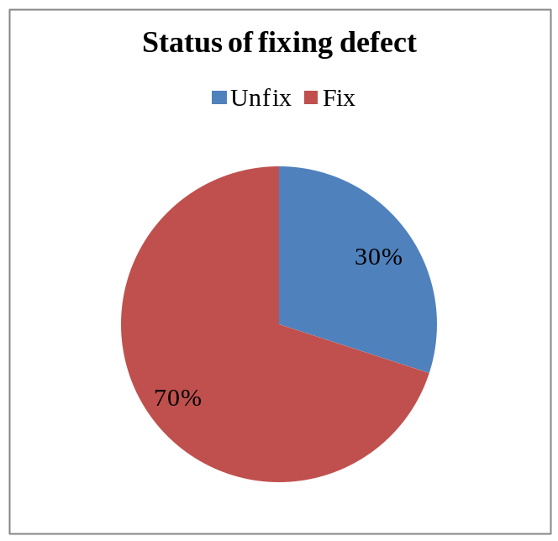
Average time to detect and fix a defect: 0.65 days for a defect (assumption 1working day/8 hour).
Time need to fix all remain defects: 19.5 days (more than two week).
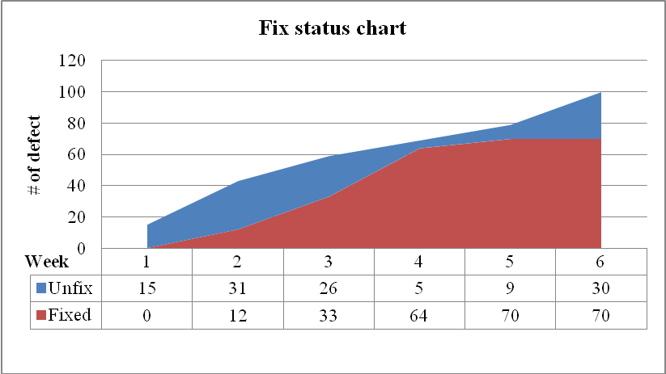
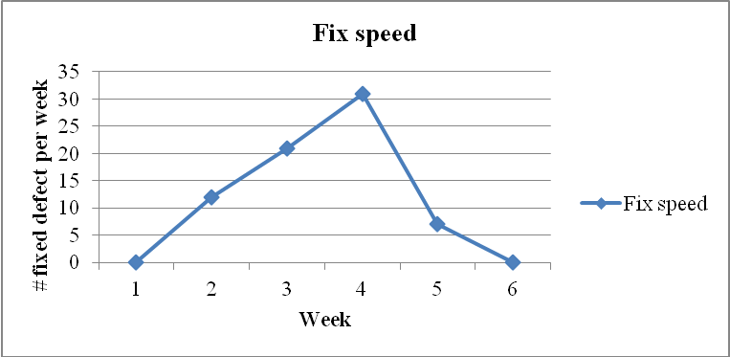
Data Extraction Cycle: Weekly during System Test or on demand through projects intranet site (last set of data points on graph show week-to-date current counts)
Reporting Cycle: Weekly during System Test
Availability: Company Confidential – For Internal Use Only

Note. From week 4 to week 6, fixing speed was decreased quickly. The reason will be explained in the following topics.

Defect by severity
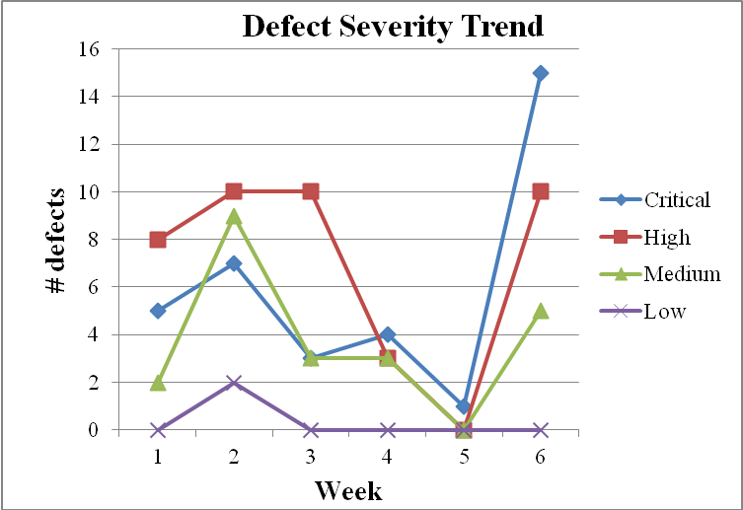
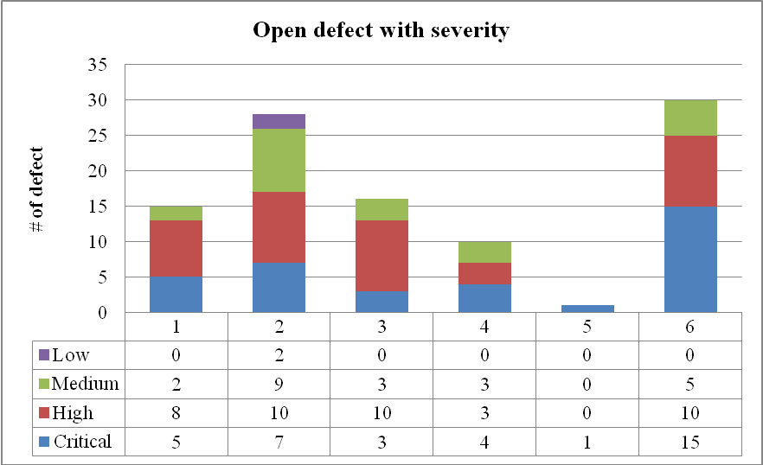
Data Extraction Cycle: Weekly.
Reporting Cycle: Weekly starting with Integration Test
Availability: Company Confidential - Internal Use only

Note. From week 5 to week 6, the open critical defects tend to increase, this is serious problem. 15 critical defects and 10 high defect can make project fail if we do not have effective solutions.
Reason why fix speed was decreased. In week 1, 2, 3, 4, number of critical defect were detected are less than week 6. In cycle, after detect defects in previous week, testers will fix them in next week. So in week 5 and 6, the number of unfixed critical defect will be increase too much.
Recommend for problem: Should prepare the following steps for situation.
- Review all of project to find the source of problems.
- Evaluate the influence of found problems.
- Estimate impact of fixing problems (prepare human resource, time for solution, budget …) (during progress, should not go on to develop project).
- Solve the problems.
- Review.

Defect by tester
 | Defect assigned | Defect fix | Time to fix (day) | Average defect fix in a day | Rate complete | Time to fix all remain defects | Average time to fix a defect
Anjuli | 32 | 27 | 37 | 0.7 | 84 | 3.5 | 1.4
Bob | 49 | 42 | 37 | 1.1 | 86 | 7.7 | 0.9

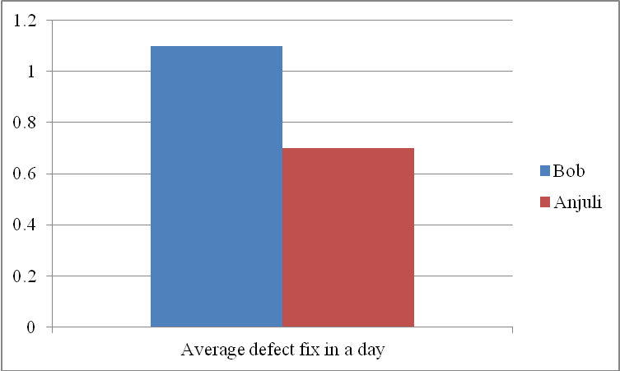
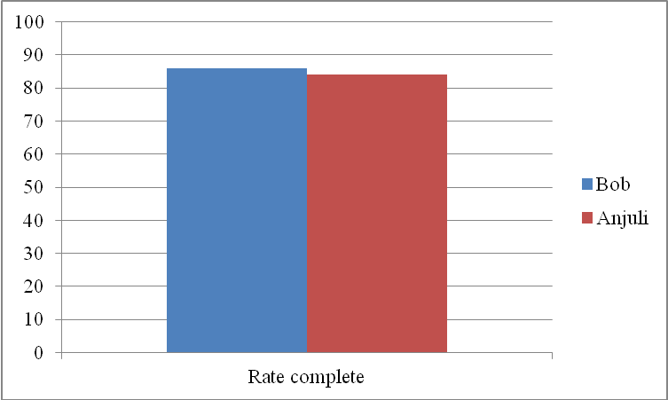
Comment
Name | Effective | Effort | Note
Anjuli | Good | Good
Bob | Very good | Good

References

